Nursery Handbook
2017/2018
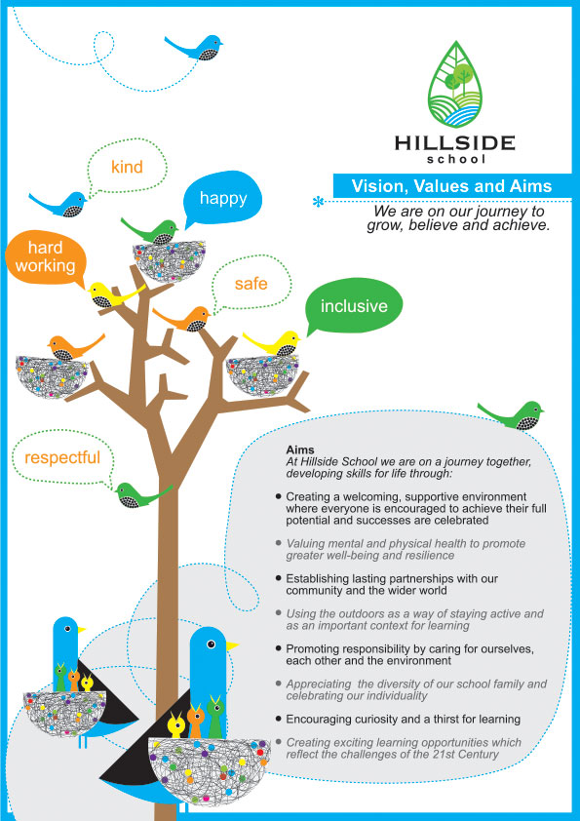
Hillside School Nursery

Dear Parents/Carers,
A very warm welcome to Hillside School Nursery! We look forward to establishing a mutually supportive partnership to ensure a happy and fulfilling time for your child. This handbook is designed to equip you with the basic information that you will need during your child’s time in Nursery. You will be kept up-to-date on a regular basis through daily contact with the Nursery Team and the noticeboard in Nursery. Please remember to look in the Nursery reception area at the displays as we are always looking to collate your views and feedback in order to ensure we are always improving and maintaining high standards.
At Hillside we currently have provision for 50 pupils in the morning and 50 pupils in the afternoon. This enables us to have the full time equivalent of three Early Years Lead practitioners (EYLP) and two Early Year Practitioners (EYP). We will also have a part time EYP who will cover the staff lunch period.
We hope your child will be happy with us and will respond to the many opportunities for learning which we offer in the Nursery. We look forward to having you and your child work with us and hope that this will be the start of a strong partnership.
Miss Lesley-Anne Munro
Head Teacher

Information
Address Hillside School
Newlands Drive
Portlethen
AB12 4LX
Telephone: 01224 472850
Email: www.hillside.sch.aberdeenshire.gov.uk
Hours of Opening
Morning Session:
8.45 (drop off until 9.00) - 11.55 (collection from 11.40)
Afternoon Session:
12.25 (drop off until 12.40) - 15.35 (collection from 15.20)

Group sessions:
The Otters and The Squirrels:
- Monday, Tuesday and Wednesday morning
- Thursday and Friday afternoon
The Hedgehogs and The Badgers
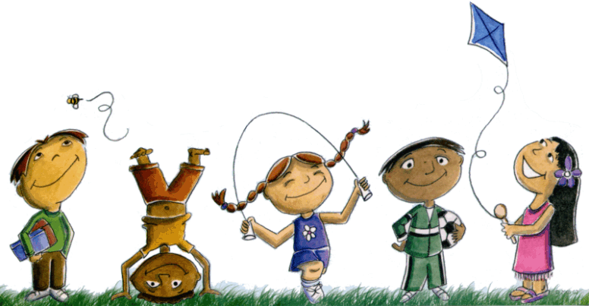
- Monday, Tuesday and Wednesday afternoon
- Thursday and Friday morning

Staff
Our Staff Team (August 2017)
Miss Lesley-Anne Munro Head Teacher
Jordan Leslie Depute Head Teacher
Mrs Lorraine Gill Principal Teacher (EY) Portlethen Cluster
Mrs Kay Muir Early Years Lead practitioner (EYLP)
Debbie McDermott Early Years Lead practitioner (EYLP)
Mrs Michelle Forbes Early Years Practitioner (EYP)
Errin Nelson Early Years Practitioner (EYP)
Anne Ritchie Early Years Practitioner (EYP)
Ala Milne Early Years Practitioner (EYP)
Mrs Jenny Riddoch School Administrator
Mrs Michelle Duffy Admin clerical assistant

Arriving & Leaving
The Nursery morning sessions are 8:45 – 11.55am and the afternoon sessions are 12.25 – 3.35pm. You are welcome to speak to the Nursery staff upon drop-off and pick-up. Should you wish to discuss your child or any issues in more detail, you can ask to make an appointment for a more suitable time. We operate a flexible arrival and collection policy and allow a 15 minute window at the beginning and end of each session for parents to drop off and collect their children. Children should always be taken to and collected from the Nursery classroom by a responsible adult. We have a signing in and out system is in place. We cannot release your child into the care of a person other than yourself without your instruction. Please let us know who will be collecting your child. As there is only a short turn around period for the staff to be prepared for each session, may we ask that children are collected promptly at the end of the morning session.
What your child needs for nursery.
Your child will require the following items:
- Soft non-slip gym shoes
- A small, named bag to hold shoes and change of clothes
- A change of clothes that are labelled
- A waterproof jacket
- Snack money which is collected termly (monthly by arrangement)
Please help us by making sure that any personal belongings are clearly named. If you do lose something please look in the ‘Lost Property’ box located in our entrance. To cater for energetic, physical outdoor activities or walks around the local environment children should always be provided with appropriate outdoor clothing. We encourage children to become independent when dressing and when going to the toilet so please refrain from dressing your child in tricky buckles, braces or buttons! It is not advisable for children to wear jewellery in the nursery. We do insist that children wear an apron during art and craft activities and when playing in the water but accidents do happen, please do not dress your child in their best clothes.
Please make sure everything your child brings to Nursery is clearly labelled with their name.
The pegs in the cloakroom are shared so we ask your child brings their bag each day.

Outdoor play and walks
The children are taken outside regardless of the weather so please ensure your child is suitably dressed for outdoor activities. A jacket is essential as well as suitable shoes or boots.

Snack
Your child receives a small snack each session. The snack menu is on display in the nursery entrance. Staff ensure that snacks are balanced, nutritious and varied. If you have any new ideas for our snack menu, please let us know. A choice of milk or water is offered and fresh fruit or vegetables are served daily. Children are encouraged to sample the food and chat about their likes and dislikes. During snack time, emphasis is placed on hygiene, enjoying food, early language and early mathematical concepts and the creation of a sociable scene for the children. Snack money is paid on a termly basis. We make a charge of £2.50 per week to cover costs. If your child is allergic to any food or should not eat a particular food for religious reasons, please inform a member of the nursery staff. The staff have “Food and Hygiene Certificates” so we can ensure that there is a high standard of hygiene in our nursery.

The Nursery staff will issue parents with a snack envelope each term with the amount required to cover costs of snack.

Tooth Brushing
Each child will regularly brush their teeth at Nursery. We work closely with our NHS Oral Health Co-ordinator who visits the Nursery regularly to talk to children about good oral hygiene and ensures children are encouraged to use correct technique when brushing teeth. Nursery provides each child with their own toothbrush and toothpaste.
The Nursery Curriculum
We want our nursery to be a friendly and welcoming place and our aim is that your child will enjoy the experience of nursery. The nursery staff work together as a team to create a caring and stimulating environment where each child can develop as an individual. Our nursery curriculum is based on “Curriculum for Excellence” which is published by the Scottish Government and Education Scotland. We also adhere to Aberdeenshire’s Framework for Learning. These documents provide schools with guidance for learning and teaching of children aged 3 – 18 years. These documents describe the wide range of learning experiences to which preschool children are entitled. They emphasise partnership with parents. Our nursery team firmly believes in building upon your child’s prior learning. The aim of pre-school education is to develop and broaden the range of children’s learning experiences, to encourage them to become confident individuals, responsible citizens, successful and enthusiastic learners who are looking forward to continuing their learning journey throughout primary and secondary school.

The nursery curriculum places a careful emphasis upon the nurturing of your child’s social and emotional development. Health & Well-Being is firmly placed at the core of a holistic approach to child development. It also includes the development of your child’s early language and communication skills and development of early mathematical & numeracy skills and knowledge. We offer carefully planned experiences, which build upon his/her knowledge and understanding of the world and promote his/her creative and physical abilities.

The curriculum document identifies key aspects of children’s development.
• Expressive Arts
• Health and Wellbeing
• Languages
• Mathematics
• Religious and Moral Education
• Sciences
• Social Studies
• Technologies
Young children learn through play and practical experience. ‘Hands on’ activities allow children to explore; investigate; experiment; act out experiences and listen and learn from others. Staff interact sensitively to extend the quality of play and act as role models when appropriate. At Hillside our planning process includes mind mapping in floor books and the children are encouraged to take responsibility for their own learning so that we can plan activities that provide the highest quality of educational experiences. We value and aim to build upon each child’s previous learning experiences and recognise the need to establish strong parental partnerships to support their development. Learning happens throughout nursery, the nursery outdoor learning area, areas in school (eg library, garden, playground, gym hall) and through walks in the community.

Parental Engagement
We consider our daily contact with parents and carers to be vitally important – a time for both of us to exchange information.
After the initial settling in period there will be opportunities for you to help in the nursery and on walks and outings. Lists will be displayed on the class notice board and you are invited to discuss with the nursery staff ways in which you can share your child’s pre-school learning experiences. If you would like to help in Nursery, you will need to complete a PVG form. (See School Office).
Throughout the year there will also be more formal opportunities for you to discuss your child’s progress with staff on an individual basis. Please remember that if you are concerned about anything, however small, do not hesitate to come in and talk about it.
At Hillside we have an active Parent Council (Hillside Parent Group). We welcome all parents to attend meetings and become involved in school decision making, discussions and fund raising events. All find raising goes towards supporting the school with help towards the cost of trips, workshops and equipment for our learners.

Health
At the initial meeting with your child’s teacher in April you will be able to let us know about any special circumstances relating to your child’s health. Please keep your child at home if he/she is not feeling well and let us know by phoning the Nursery direct (telephone number at the end of this booklet) if he/she is going to be off. Nursery is a busy and sometimes noisy place, and not an appropriate place to be if your child is feeling under the weather. Not only will their capacity to learn and enjoy themselves be compromised, but there is the possibility that they may pass illness and infection to staff and their classmates. If your child becomes unwell at Nursery we will contact you to take him/her home. You can understand that it is vital that school always has up-to date details of how to contact you or a friend or relative. We ask for two emergency contact numbers.
Children who have had sickness or diarrhoea should not return until 48 hours after the last bout.
Should your child require medication whilst at Nursery, you will need to fill out a form after which medication may be kept within Nursery to be administered as and when necessary. Should your child have a small accident whilst at Nursery, we will administer appropriate first aid and make a note of the details in our accident book. You will then read and sign this at the end of the session, keeping a copy should you need to refer to it at any time. On very rare occasions, children may hit their head or have a slightly more serious mishap whilst at Nursery. Under these circumstances you will be called immediately – we like to err on the side of caution.

CHILD PROTECTION STATEMENT / POLICY ADVICE
Everyone has a responsibility to protect children from harm. School staff members are in a unique position to contribute to the protection of children and must share concerns with appropriate colleagues and agencies. Every school has a Designated Officer who has been specially trained to listen to concerns and act on them as necessary. Unless satisfied that a child has not been harmed or is not at risk of being harmed, the school must relay their concerns immediately to the social work service and/or the police. Social work and the police will determine when and how the child’s parents/carers and other services are to be informed of the concerns.
Local Social Work Office - Portlethen
Address & Telephone No. Rowanbank Road, Portlethen, AB12 4NX. (01224 666200)

SCHOOL PUPILS INSURANCE
No insurance cover is held by Aberdeenshire Council to provide automatic compensation to pupils in the event of a personal accident or death. It is your responsibility as a parent to insure your child for personal accident or death if you feel this is appropriate. The Council does hold third party liability insurance, which indemnifies the Council for claims from third parties (e.g. parents of pupils) who have suffered injury, illness, loss or damage arising from the negligence of the Council or its employees. However if there were no negligence, no claim would be accepted by the Council. Please make sure the school always has up to date details of how to contact you, a friend or relative. We ask for two emergency contact numbers. In this time of ever changing mobile phone numbers, it is vital that you tell us of any changes to our contact information. 10 School and Staff Information.

Nursery Policies
Hillside School Nursery Policies follow school, local authority and national guidelines. Policies are reviewed and updated regularly. All policies are available to view in nursery reception/cloakroom area and are available from the school office.

